Computer Language Coding Concepts

System Interface of a Related List
When you open up the system interface for a Related List, you get to see the system commands that apply to Related Lists. Only the List aspect applies to Related Lists. The system interface of a Related List will show the Add command. The Add command has an optional Item argument, to add an existing item to the list.

So the system interface of a Related List looks like this:

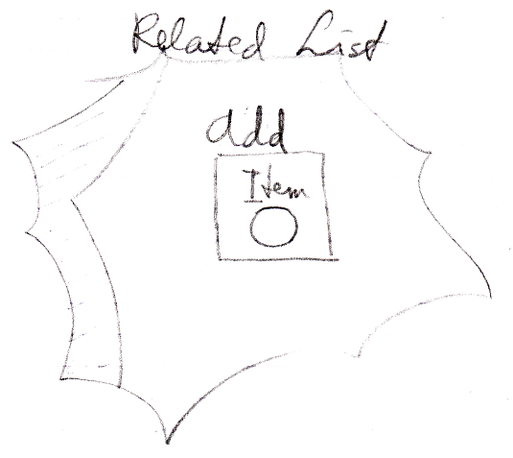

But more members may be introduced later.

Author & Copyright: Jan-Joost van Zon Date: August 27, 2009 – August 27, 2009 Location: Oosterhout, The Netherlands Status: Finished

